|  |
| --- |
|  |

PROJECT REPORT

*ON*

##### Study Smart

Towards partial fulfillment of the requirement

For the award of degree of

###### Bachelor of Computer Application

Submitted by under Guidance of

Arjita Verma Mr. Amit srivastava

ID : 716002

Academic Session 2016– 19

Department of Computer Science



**National P.G. College**

**(An Autonomous College of Lucknow University)**

**(NAAC ‘A’ Grade Credited)  
2- Rana Pratap Marg,Lucknow**



**National P.G. College**

**2, Rana Pratap Marg, Lucknow(U.P.)**

**CERTIFICATE**

This is to certify that project report entitled

**Study Smart**

being submitted by

**Arjita Verma**

Towards partial fulfillment of the requirement

For the award of degree of

**Bachelor of Computer Application(BCA)**

In the Academic Session: 2016-2019

Is a record of students own work

And to the best of my knowledge the work reported here in does not form a part of

Any other thesis or work on the basis of which degree or award was conferred on

An earlier occasion to this or any other candidate

**Mrs. Shalini Lamba**

**H.O.D(Computer Application)**

CANDIDATE DECLARATION

I, hereby certify that the work which is being presented in the project work entitled “Study Smart” is the fulfillment of the requirement for award of the Bachelors in Computer Applications submitted in the Computer Science Department of National P.G. College.

This is an authentic record of my work during 6 months period under supervision of Mr. Amit Srivastava

The matter presented in the project work has not been submitted by me for the award of any other Degree/Diploma of this or any other University.

Date : / /2019

Place : Lucknow **(Signature of Candidate)**

**Acknowledgement**

The satisfaction and euphoria that accompany the development of any task would be incomplete without the mention of the people who make it possible, whose constant guidance and encouragement crowned our efforts with success.

We, the developers feel indebted to a lot of people who during the course of our project not only held us in good stead but also provided us with invaluable services both personal and professional.

At this juncture, when we, at the successful completion of our project are presenting our report it would be unfair not to acknowledge the various acts of kindness done to us by our teachers. They were always present on our every beck and call to help us out of every hurdle and obstacle that we faced.

Our first vote of thanks goes to our Parents, with every gesture, every word, every pat on the back, they have always tried to inspire us for better things and attain them. More so with this project, they were with us every instant, sharing our joys-when the code used to work and wiping our tears when machine used to hang.

We wish to place on record our whole hearted gratitude to our project guide Mr. Amit Srivastava for making available every facility that we required during the course of our project. Also, we are extremely thankful to you Sir, for extending your kind guidance and words of wisdom from your treasure trove of experience. With friendly advice and guidance at every step, his presence was a welcome sight through out the project. .

Thank you Sir.

We are also deeply indebted to our (HOD) Mrs Shalini Lamba for her constant presence, supervision and advice paid off in the culmination of this project and has helped us a great deal with this project with her constant words of encouragement and advice.

Actually, this project report is just an excuse to convey our feelings about how much we appreciate the amount of concern and caring that our teachers exhibit in all our pursuits ranging from anything as simple as the routine lab program to something as taxing as a project. Their patient listening to our problem is itself a major source of strength to us.

Thanks to all of u….

Finally, we would like to bind up by paying our heartfelt thanks and prayers to the Almighty, without whose willing nothing is possible in this world and all my dear friends for their support.

# 1. Introduction and Objectives

## 1.1 Statement of The Proposed System

Study Smart provides a very flexible way to tackle the service related issues. Every solution to the service related problems is here. One does not have to handle issues with the general helpers, we are here to do so. We also ensure the security problems with the workers or the helpers.

Our services are quick and we try to be always on time. A contented customer is all we want.

## 1.2 Problem With Existing System

When it comes to our static needs or taking care of somebody or something, it’s always a concern. Inspite of being the technology at such pace, there occurs tediousness in finding a good and trustworthy person to carry our work. Our housewives arranges rounds of interviews just to hire a well-trained maid. A person in need of an urgent driver has to go through a lot complexes. The organisations like Orphanages and old age homes has to fix up for their workers and employees.

Considering all, there has to be a medium where all of it can be availed at ease.

**Area Constraint:**  Helpers are available in some of the post and particular areas.

**Late Replies:** The communication between helper , customer and the organization is not very frequent.

**More Confusion:** Because of the proper communication gap , a rythm among helper,customer and the organization is not very compatible.

**Search Criteria’s not matching**: From helpers point of view , they are not given the work according to their location . They have to travel long distances to provide the services

## 1.3 Objective of the Project

* + - To provide computer study material to students such as previous year question papers, mock papers, notes and the content of a particular topic.
    - To provide a plateform to registered tutors to share and upload their notes.
    - To provide registered students to not only view the content but also download and access papers and study material available on the site.
    - To provide proper communication plateform between registered students and tutors
    - To provide a interface where registered user can give their feedbacks regarding the content and study materials.

## 1.4 Project description

Study Smart is a website, which mainly focuses on computer background students of High School and Intermediate. It provides a guide of computer subject to the students along with the question papers . The main objective of this website is to help the students especially the students appearing for boards . It also helps the students in solving their queries by providing them previous years questions papers ,mock papers,,notes and by connecting them with the teachers . It also provides a interface between teachers and students where they can ask and solve queries .Our website also provides a section for teachers where they can register and upload papers and their notes which will help the students.

**Proposed System:**

### Webpages for

1. Admin Login
2. Admin Dashboard
3. Insert Class
4. Insert Language
5. Insert Content
6. Insert Question Paper
7. Insert Mock Paper
8. Insert Notes
9. View Contact Us
10. View Tutor
11. View User
12. User Sign Up
13. User Sign In
14. User Account
15. Tutor Sign In
16. Tutor Sign Up
17. Tutor Account
18. Home Page
19. View Question Papers
20. View Mock Papers
21. View Notes
22. Latest Mock Papers
23. Latest Question Papers
24. Latest Notes
25. View Content
26. Feedback
27. Contact Us
28. About Us
29. Database management
30. Administration

2. System Analysis  
 2.1 Requirement Analysis:

Some of the major requirements gathered are as follows-

1. Administrative activity must be performed by the authenticated administrator.
2. Only Admin can delete a user , helper , city ,locality etc, with different privileges to use the website.
3. Only the registered user can edit /make changes to his/her profile .
4. All users registered must have valid and existing email.
5. All member id generated must be unique and randomly generated
6. Accurate information must be provided , in the user registration.
7. A user cannot view the profile of other user.
8. A user dashboard must be there which include all links to various services provided to users.
9. Users must be given option to enter their success story
10. Users must be provided choice of subscribing to Featured Profile
11. The administrator must be able to view all the information about user and, edit as per the need.

### User Interface Requirement:

* User Interface elements must be easy to understand.
* The user interface should be easy to learn. When users use the interface, they should know which element is used for which operations.
* The interface actions and elements should be consistent. When users press any button, required actions should be performed by the system alongwith appropriate prompts to the user.
* The screen layout and color of the user interface should be appealing. When users look at the screen, it should have a nice vision. Colors should be selected clearly and intelligently, thus providing an appealing and comfortable look and feel to the user.

## 2.2 Risk Analysis:

Uncertainity, which is constantly present in our daily lives, frequently impacts our decisions and actions.  When we talk about risk, we normally mean the chance that some undesirable impact will occur.  Hence, we normally seek to avoid or minimize risk.  If there is a chance of rain, and we don't want to get wet, we may choose to stay indoors -- avoiding that risk -- or we may take an umbrella to minimize the impact of rain upon us. Uncertainity can impact our decisions and actions in desirable as well as undesirable ways.  In risk analysis we usually focus on what can go wrong -- the outcomes that represent loss or damage -- although an effective analysis will also help us understand what can go right as well.

A risk assessment involves evaluating existing physical and environmental security and controls, and accessing their adequacy relative to the potential threats of the organization. A business impact analysis involves identifying the critical business functions within the organization and determining the impact of not performing the business function beyond the maximum acceptable outage. Types of criteria that can be used to evaluate the impact include: customer service, internal operations,

legal/statutory and financial.

A primary objective of business recovery planning is to protect the organization in the event that all or part of its operations and/or computer services is rendered unusable. Each functional area of the organization should be analyzed to determine the potential risk and impact related to various disaster threats.

Regardless of the prevention techniques employed, possible threats that could arise inside or outside the organization need to be assessed. Although the exact nature of potential disasters or their resulting consequences are difficult to determine, it is beneficial to perform a comprehensive risk assessment of all threats that can realistically occur to the organization. Regardless of the type of threat, the goals of business recovery planning are to ensure the safety of customers, employees and other personnel.  
Uncertainity can arise in several ways:

* If the quantity we'd like to know is a competing firm's planned product price, uncertainty arises from our **lack of knowledge**:  The price may be well known to that firm's employees, but it's unknown to us.
* If the quantity is market demand for products like ours, uncertainty arises from the **complexity of the process**:  Demand depends on economic factors, fashions and preferences, and our and other firms' actions -- and even if we knew all of these, we couldn't fully calculate their net impact on final demand.
* If the quantity is information shared with us uncertainity may arise with the authenticity of the information provided.  We may also have limits on our **ability to authenticate the information.**.

.

# 3. Preliminary Investigation

Preliminary system study is the first stage of system development life cycle. This is a brief investigation of the system under consideration and gives a clear picture of what actually the physical system is? In this stage the need of the system is evaluated. The initial system study involves the preparation of a ‘Project Overview’ which lists the Problem with the existing system, Objectives of the proposed system, Scope of the proposed System, Constraints, Expected benefits of the new system, etc. in the light of the user requirements. The main steps followed in this stage are:

* Problem identification and project initiation.
* Background analysis.
* Inference or findings (system proposal).
* Determine the size of the project.
* Assess costs and benefits of CREATEnative approaches.
* Determine the technical feasibility of CREATEnative approaches.

# 4. Project Feasiblity

Feasibility is said to be the determination of whether the project is worth doing or not. The process followed in making this determination is called feasibility study. Feasibility study determines if a project can and should be taken or not. Will it be beneficial and practical for the organization to take such a project. Once it has been determined that the project is feasible, the analysts can go ahead and prepare the project specification which finalizes project requirements.

The duration of time required for the project has been planned appropriately and it is the same as expected. Therefore the “**Study Smart**” – a service website can be launched on the web within the expected time duration, satisfying the needs.

Hence the project is feasible in scheduling.

### Feasibility Consideration

#### Types of Feasibility Study:-

###### Technical feasibility

###### Operational feasibility

###### Economic feasibility

###### Schedule Feasibility

### Steps Involve in Feasibility Study

##### Technical Feasibility:

Technical feasibility is concerned with specifying equipment and hardware and software requirements for the system development that will successfully satisfy the user requirement.

The technical needs of the system may include:

* The facility to produce outputs in a given time.
* Response time under certain conditions.
* Ability to produce a certain volume of transaction at a particular speed.
* Facility to communicate data to distinct location.

Like in this website“**Study Smart**”following hardware and software requirements must be fulfilled:

**Database Design** : SQL Server 2008 R2

**Interface Design** : Visual Studio 2012 with 4.0 framework

**Coding**: : C# with ASP.Net

Specific software and hardware products can then be evaluated keeping in view with the logical needs.

The website “**Study Smart**” is technically feasible as all the software and hardware requirements are met by the organization.

##### Operational Feasibility:

Operational feasibility determines how the proposed system will fit in with the current operations and what will happen if any; process reconstruction or retraining of the specified user’s may be needed to implement the system. The evaluation must then determine the general attitude and skills of existing personnel and whether any such reconstruction of processes will be acceptable to the current users.

Operational Feasibility deals with the user interaction with the system and how the changes in the system may lead to the feasibility of the system. Will the system work accordingly and give fruitful results this is the main objective of this feasibility study.

It also focuses on the database management and how the information so stored is managed by the system.

The “**Study Smart Website**” is found to be feasible operationally because it is designed in such interactive manner that user need not to take any special training for operating the website.

##### Economic Feasibility:

Economic analysis or cost/benefit analysis is most frequently used technique for evaluating the effectiveness of a proposed system. It is procedure to determine the benefits and savings that are expected from the proposed system and compare them with costs. If the benefit outweighs the costs, a decision is taken to design and implement the system. Otherwise, further justification or CREATEnative in the proposed system will have to be made if it is to have a chance of being approved. This is an ongoing effort that improves in accuracy at each phase of system life cycle.

A system so developed must be economically feasible so as to be beneficial for the organization The economical factor for “**Study Smart Website**” is feasible as all the resources used for its development lie within the budget estimated for its development.

##### Schedule Feasibility:

This feasibility study deals with scheduling all the processes development so as to get the fully working and well developed system at the end without any loop holes in its processing. This study checks the whether all the processes are integrated and the work flow is as per the requirements.

## 5. Methodology Used

### Technologies Used:

##### Net Framework 4.0

.NET is a application framework developed and marketed by Microsoft to allow programmers to build dynamic web sites, web applications and web services. It was first released in January 2002 with version 1.0 of the .NET Framework, .NET is built on the Common Language Runtime (CLR), allowing programmers to write ASP.NET code using any supported .NET language.

##### C#

C# (pronounced C-Sharp) is a new programming language introduced with the Microsoft .NET framework and is no doubt the language of choice in .NET environment. It was first created in the late 1990's as part of Microsoft’s whole .NET strategy. It is a whole new language free of backward compatibility curse and a whole bunch of new, exciting and promising features. It is an Object Oriented Programming language, which at its core, has similarities with Java, C++ and VB.

In fact, C# combines the power & efficiency of C++, simple & clean OO design of Java, and code simplification of Visual Basic. Like Java, C# also does not allow multiple inheritance and use of pointers (in safe and managed code) while it does provide garbage memory collection at runtime, type and memory access checking. But, contrary to java, C# keeps the different useful concepts of C++ like operator overloading, enumerations, pre-processor directives, pointers (in unmanaged and un-safe code), function pointers (in the form of delegates), also promises to have template support (with the name of generics) in next versions. Like VB it also supports the concepts of properties (context sensitive accessor to fields).

In addition to this, C# comes up with some new/exciting features like reflections, attributes, marshalling, remoting, threads, streams, data access with ADO.NET, etc. C# programming language is designed from the scratch keeping in mind the Microsoft.Net environment. MS.Net (and thus C#) programs runs on top of the Common Language Runtime (CLR), which provides the runtime support to them.

##### Database Server: MS- SQL Server 2008 R2

**Microsoft SQL Server** is a relational database server, developed by Microsoft: it is a software product whose primary function is to store and retrieve data as requested by other software applications, be it those on the same computer or those running on another computer across a network (including the Internet). There are at least a dozen different editions of Microsoft SQL Server aimed at different audiences and for different workloads (ranging from small applications that store and retrieve data on the same computer, to millions of users and computers that access huge amounts of data from the Internet at the same time).

**4. ASP.NET Web Forms Model**

ASP.NET web forms extend the event-driven model of interaction to the web applications. The browser submits a web form to the web server and the server returns a full markup page or HTML page in response.

All client side user activities are forwarded to the server for stateful processing. The server processes the output of the client actions and triggers the reactions.

Now, HTTP is a stateless protocol. ASP.NET framework helps in storing the information regarding the state of the application, which consists of:

* Page state
* Session state

The page state is the state of the client, i.e., the content of various input fields in the web form. The session state is the collective information obtained from various pages the user visited and worked with, i.e., the overall session state. To clear the concept, let us take an example of a shopping cart.

User adds items to a shopping cart. Items are selected from a page, say the items page, and the total collected items and price are shown on a different page, say the cart page. Only HTTP cannot keep track of all the information coming from various pages. ASP.NET session state and server side infrastructure keeps track of the information collected globally over a session.

The ASP.NET runtime carries the page state to and from the server across page requests while generating ASP.NET runtime codes, and incorporates the state of the server side components in hidden fields.

This way, the server becomes aware of the overall application state and operates in a two-tiered connected way.

## 6. Software and Hardware Requirement

### Requirement Specification

The system should have an OS capable enough to support .NET 4.0. The detailed requirements are given in the next section which specifies the minimal requirement to run the product.

### Tools/ Platform/ Software and Hardware Specification :

##### Software Requirement:

**Server**

* + Browser : IE 10.0 or later
  + Database : MS SQL Server 2008 R2
  + Operating System : Windows XP SP3/7/8/8.1 or above

**Client**

* Browser : IE 10.0 or later,chrome,opera
* Operating System : Window XP SP3 or above

**Developer**

* Browser : Google Chrome and Firefox
* IDE : Visual Studio 2012
* Database : MS SQL Server 2008 R2
* Operating System : Window 7
* Documentation tool : MS Word, MS Power -point

##### Hardware Specification:

**Server**

* Processor : 2 .5 (GHz) Pentium processor
* RAM : 2 GB
* HDD : 80GB
* Display : 1024 x 768 High color-32-bit

**Client**

* Processor : 1.0 GHz
* RAM : 1 GB
* HDD : 10 GB
* Display : 1024 x 768 High color-32-bitSOFTWARE

**Developer**

* Processor : 2 GHz
* RAM : 2 GB
* HDD : 80 GB
* Display : 1024 x 768 High color-32-bit

## 7. SYSTEM DESIGN

### System Life Cycle

To solve actual problems in an industry setting, software engineer or a team of Engineers must incorporate a development strategy that encompasses the process, methods, and tools layers. This strategy is often referred to as a process model or a software engineering paradigm.

A process model or a software engineering is chosen based on the nature of the project and application, the methods and tools to be used, and the controls and deliverables that are required.

In this project Linear Sequential Model (Water Fall Model) is used which involve steps given below:

### LINEAR SEQUENTIAL MODEL (ITERATIVE WATER FALL MODEL)

Analysis

Designing

Coding

Testing

Implementation

System Designing is the phase which is based on the user requirements and the detailed analysis of the existing system, the new system is being designed. It is the most crucial phase in the life cycle of system development. System Analysis gives the logical overview of the system and this is converted into physical system design in this phase. Normally, the system design proceeds in two stages:

* Preliminary Design Phase
* Structured or Detailed Design Phase

##### Preliminary Design Phase:

In this phase, the features of the new system to be designed are specified. The costs of implementing these features and the benefits to be derived from the system so developed are estimated. If the project is still considered to be feasible, then we move to the detailed design phase.

In the project Minion Services , initially the designs were made to develop an interactive User Interface for the end-user to register him/her on the website and to help him/her in search of a service.

##### Structured or Detailed Design:

In the detailed design phase, the detailed designing of the system take place and the serious development of the system is done covering the user’s requirements. At this stage, the design of the system becomes more structured. Structure design is a blueprint of a computer system solution to a given problem having the same components and inter-relationships among the same components as the original problem. Input, output, databases, forms, coding schemes and processing specifications are drawn up in detail.

The system design involves:

* Defining precisely the required system output
* Determining the data requirement for producing the output
* Determining the medium and format of files and databases
* Devising processing methods and use of software to produce output
* Determine the methods of data capture and data input
* Designing Input forms
* Designing Codification Schemes
* Detailed manual procedures
* Documenting the Design

### System designing approaches:

##### Top – Down designing:

The top - down designing approach starts with major components of the system. It is a stepwise refinement which starts from an abstract design, in each steps the design is refined two or more concrete levels until we reach a level where no – more refinement is possible or not needed.

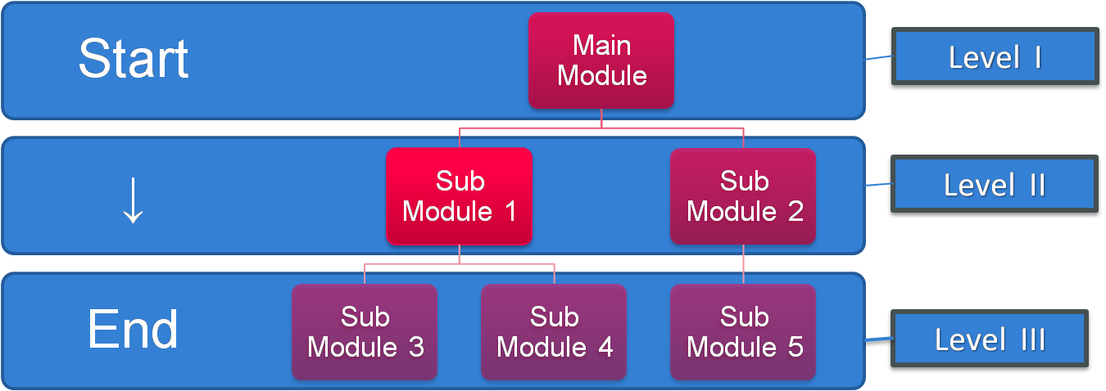

##### Bottom – Up designing:

In bottom – up designing the most basic and primitive components are designed first, and we proceed to higher level components. We work with layers of abstractions and abstraction are implemented until the stage is reached where the operations supported by the layer is complete.

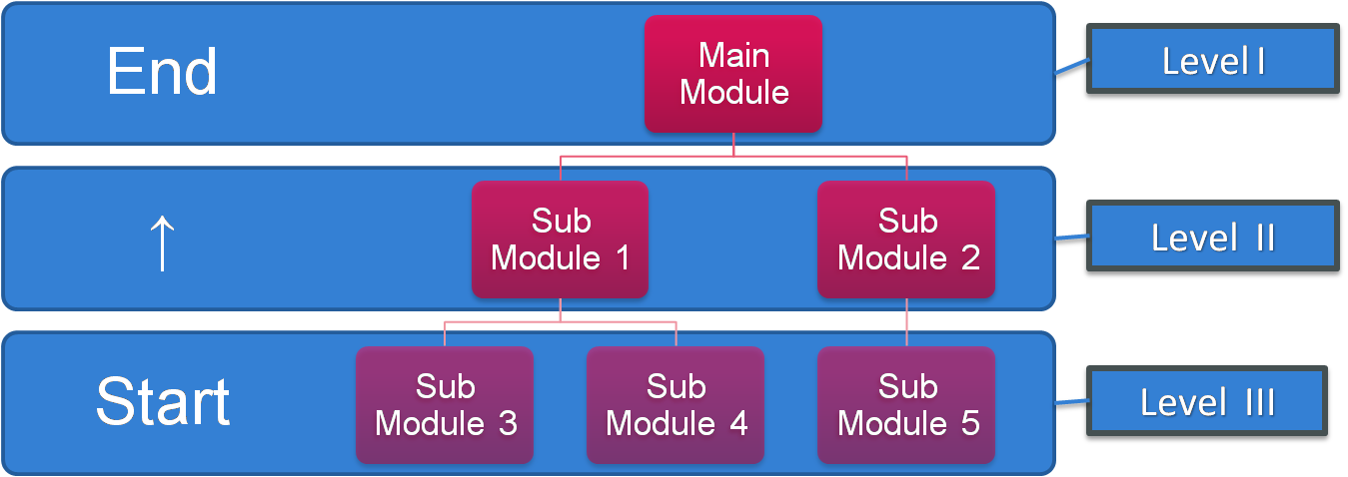

##### Prototyping Model:

### Description

It refers to the activity of creating prototypes of software applications, for example, incomplete versions of the software program being developed. It is an activity that can occur in software development. It used to visualize some component of the software to limit the gap of misunderstanding the customer requirements by the development team. This also will reduce the iterations may occur in waterfall approach and hard to be implemented due to the inflexibility of the waterfall approach. So, when the final prototype is developed, the requirement is considered to be frozen.

It has some types, such as:

* Throwaway prototyping: Prototypes that are eventually discarded rather than becoming a part of the finally delivered software

[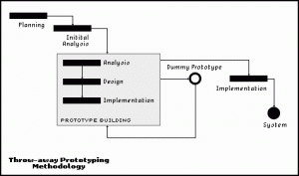](https://melsatar.files.wordpress.com/2012/03/throwaway-prototyping.gif)

* Evolutionary prototyping: prototypes that evolve into the final system through an iterative incorporation of user feedback.

[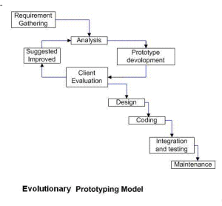](https://melsatar.files.wordpress.com/2012/03/ev-proto.png)

* Incremental prototyping: The final product is built as separate prototypes. In the end, the separate prototypes are merged in an overall design.

[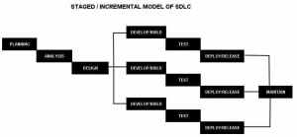](https://melsatar.files.wordpress.com/2012/03/stagedmodelofsdlc.jpg)

* Extreme prototyping: used in web applications mainly. Basically, it breaks down web development into three phases, each one based on the preceding one. The first phase is a static prototype that consists mainly of HTML pages. In the second phase, the screens are programmed and fully functional using a simulated services layer. In the third phase, the services are implemented

### The usage

* This process can be used with any software developing life cycle model. While this shall be chosen when you are developing a system has user interactions. So, if the system does not have user interactions, such as a system does some calculations shall not have prototypes.

### Advantages and Disadvantages

|  |
| --- |
| **Advantages** |
| * Reduced time and costs, but this can be a disadvantage if the developer loses time in developing the prototypes. * Improved and increased user involvement. |

##### 

|  |
| --- |
| **Disadvantages** |
| * Insufficient analysis. User confusion of prototype and finished system. * Developer misunderstanding of user objectives. * Excessive development time of the prototype. * It is costly to implement the prototypes |